# User Guidelines

## API Documentation

### Server API endpoints

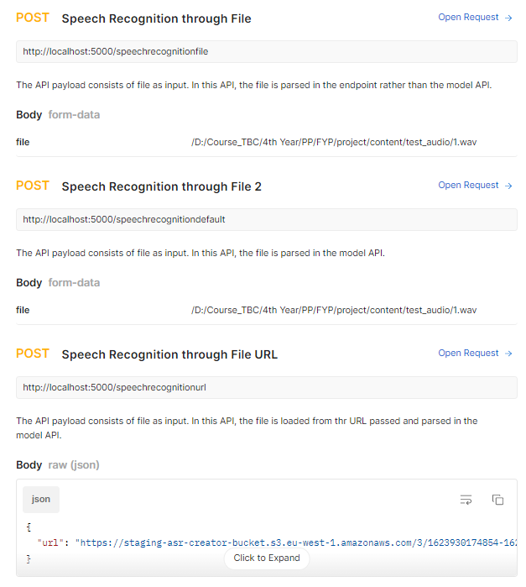

You can access the Postman API documentation at the link: **https://documenter.getpostman.com/view/9905304/Tzm5GGHa**